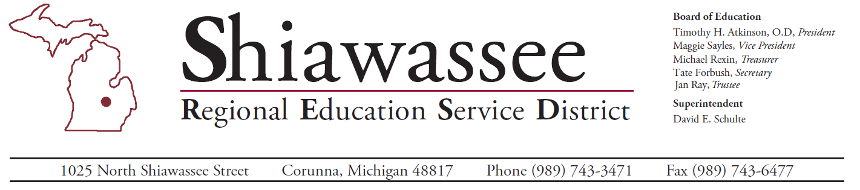

2024 – 2025 CTE Core Performance Indicators
Core Performance Indicator | State Target | Perkins Region 15 | Shiawassee County
1S1 – Graduation Rate | 95.4% | 96.7% | 96.2%
2S1 – Reading/Language Arts | 54.9% | 51.3% | 50.5%
2S2 – Mathematics | 33.2% | 20.7% | 16.5%
2S3 – Science | 13.3% | 37.9% | 33.3%
3S1 – Placement Rate | 95.1% | 94.0% | 92.2%
4S1 – Non-Traditional Concentration | 27.4% | 30.0% | 41.2%
5S1 – Credential Attainment | 8.4% | 34.3% | 17.0%

Our Mission: Provide knowledge driven, research based, direct and collaborative services that support and guide quality learning and innovation.

