- Log into EdPlan
- Select student.
- Opening page defaults to IEP Process. Select Section 4: Goals and Objectives/Benchmarks
- New window opens to Goal Page. If no goals have previously been added to the IEP, the user will see the image below. Please refer to Revising Goals and Objectives HOW TO, if user plans to revise goals already in place.

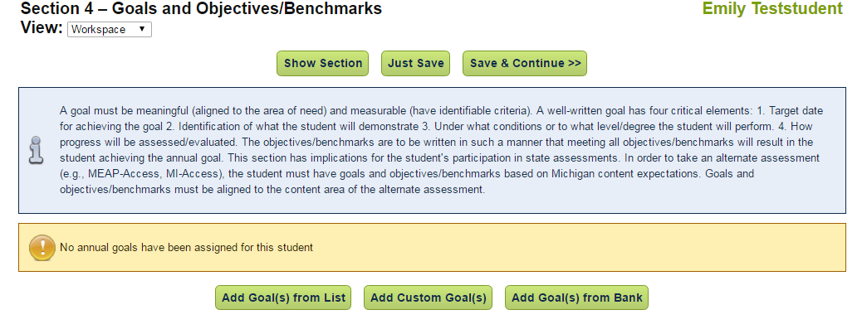
Choose option
NO Goals

ADD GOALS FROM a LIST

1. A new window opens. A compliant goal framework is immediately available. Check the box to use this basic framework and select Save and Continue. This will take the user to the IEP with a new goal available for additional information. The goal will be created in the IEP process without compliance checks for measurability. It is the case manager’s responsibility to modify the goal to meet the student’s needs and compliance standards.
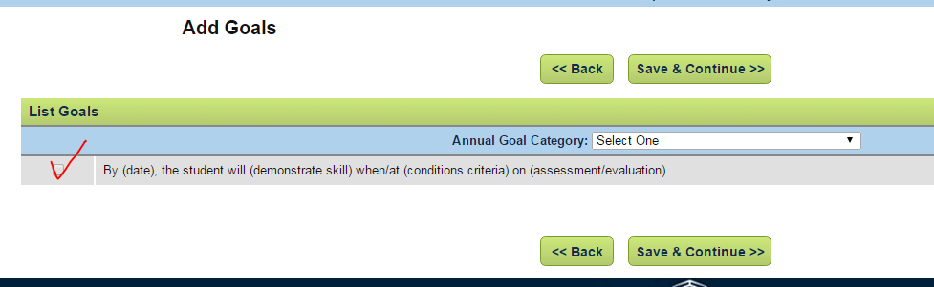

2. There are goals available from categories in the dropdown menu. See snapshot. Select Category.

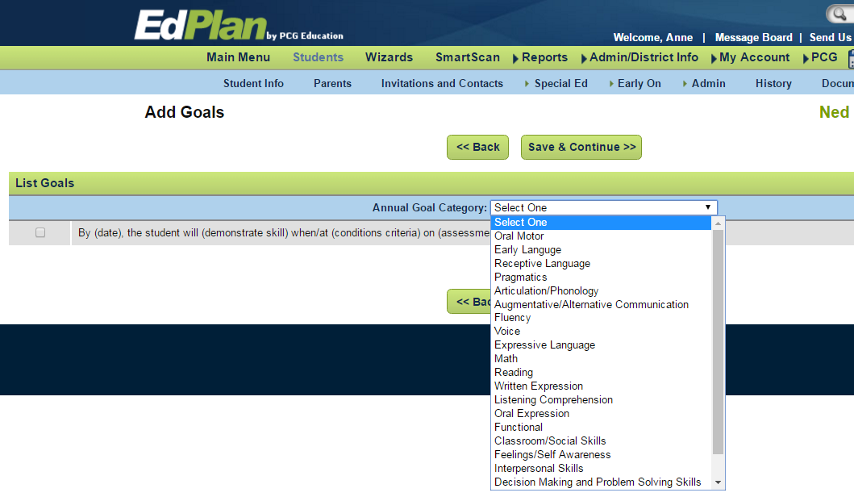

3. If written expression is chosen as a category, a new window opens with goals developed for written expression. See snapshot. Sample goals are listed in the category. Select Save and Continue to place the selected goal into the IEP.

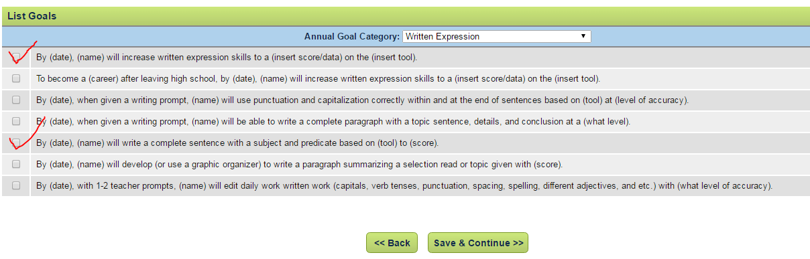

4. The goal will be created in the IEP process without compliance checks for measurability. It is the case manager’s responsibility to modify the goal to meet the student’s needs and compliance standards.

5. Here is a snapshot of a goal framework. Completing this framework will be contined in HOW TO SET THE STANDARD.
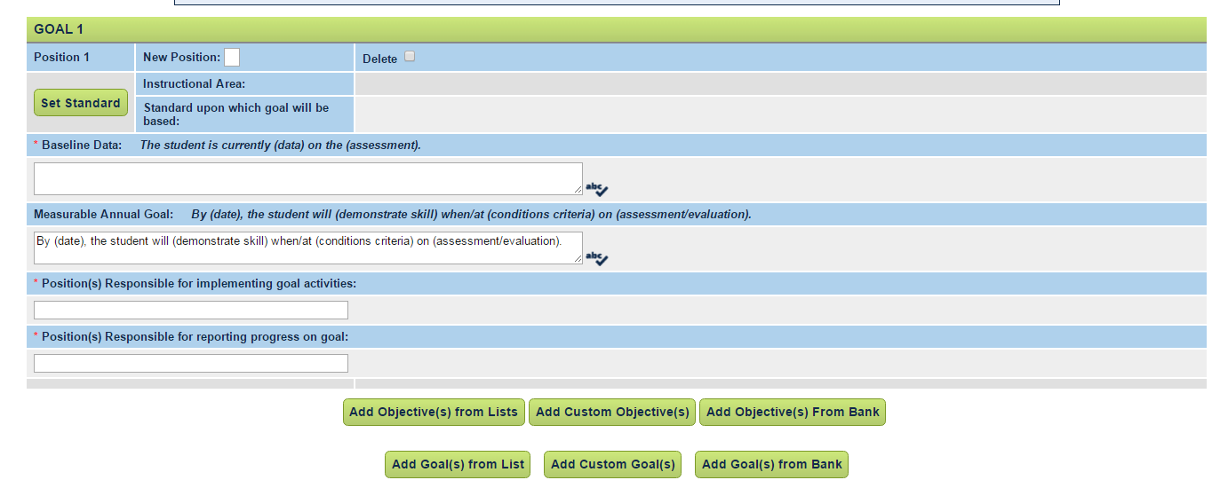
ADDING CUSTOM GOALS

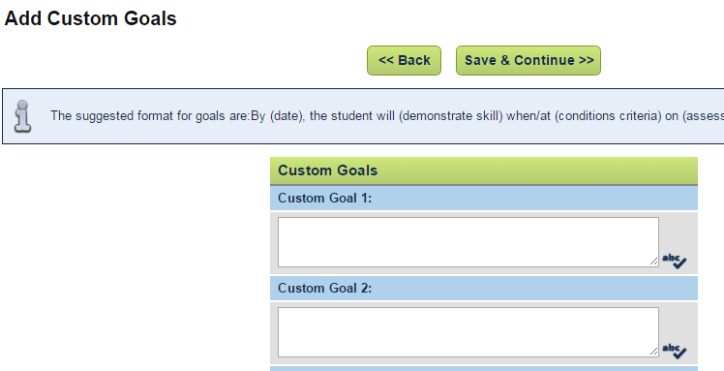

Note: When developing custom goals use the correct goal format. By (date), the student will (demonstrate skill) when/at (conditions/criteria) on assessment/evaluation tool. Save and Continue.

ADDING GOALS (Objectives) FROM A BANK
Refer to separate document: Using a Bank for Goals and Objectives HOW TO
HOW TO COMPLETE the GOAL FRAMEWORK
- Select Set Standard and choose Instructional area and Content Expectation. (See below explanation.)
- Add Baseline Data. (See below for explanation.)
- Add information to goal phrase: By ___, the student will ……. (See below for explanation.)
- Add person responsible for implementing goal: SE Teacher or Related Service Provider. (Both?)
- Add person responsible for reporting progress on goal: SE Teacher or Related Service Provider. (Both?)
- SAVE
- Select Add Objective and Save and Continue at bottom of page. (See below for explanation.)
#10 SAVE
#11
#7 #9
#6
#9
#8
#5

HOW TO SET THE STANDARD
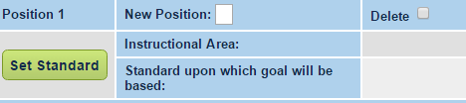
1. Select “Set Standard”. NOTE: If the student will be taking an alternate state assessment, the standards selected should be selected from the “Extended Grade Level Content Standards” (EGLCS).
2. New window opens. Open dropdown menu. Scroll to locate Instructional Area. Select.
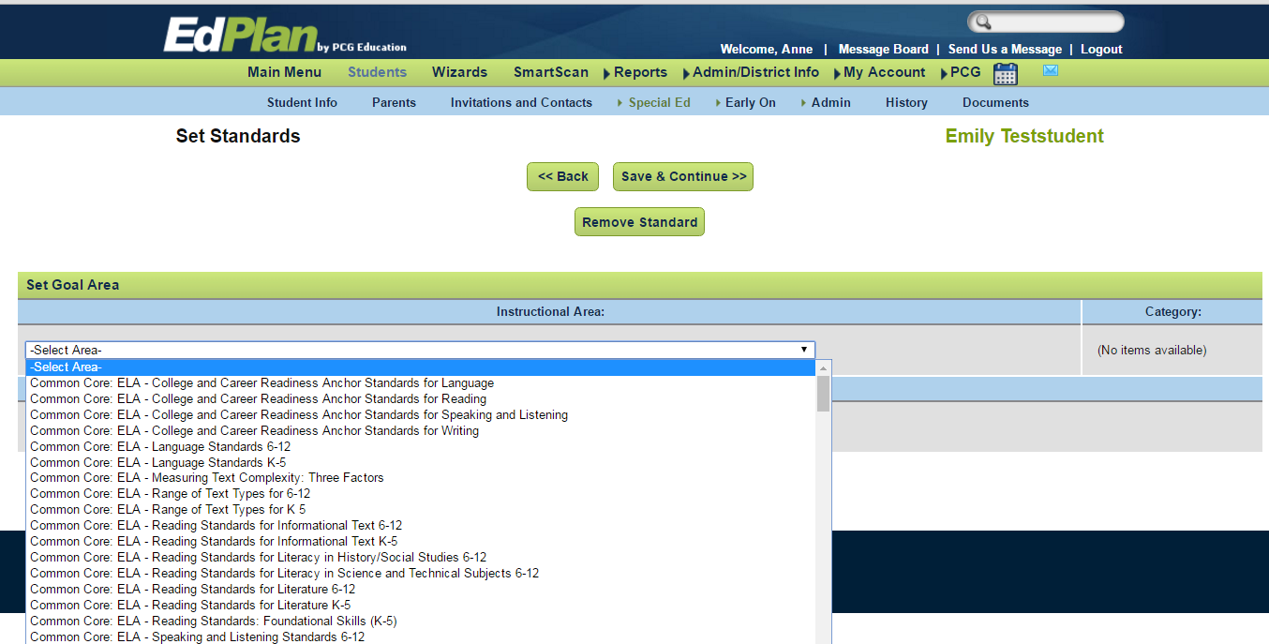
3. The screen will flash and open the Instructional Area and Category. Choose the category based on the grade the student is enrolled. The screen will flash again and the Standard will appear. Select standard. See snapshot below. Select Save and Continue. The selected items will fill into the goal framework.
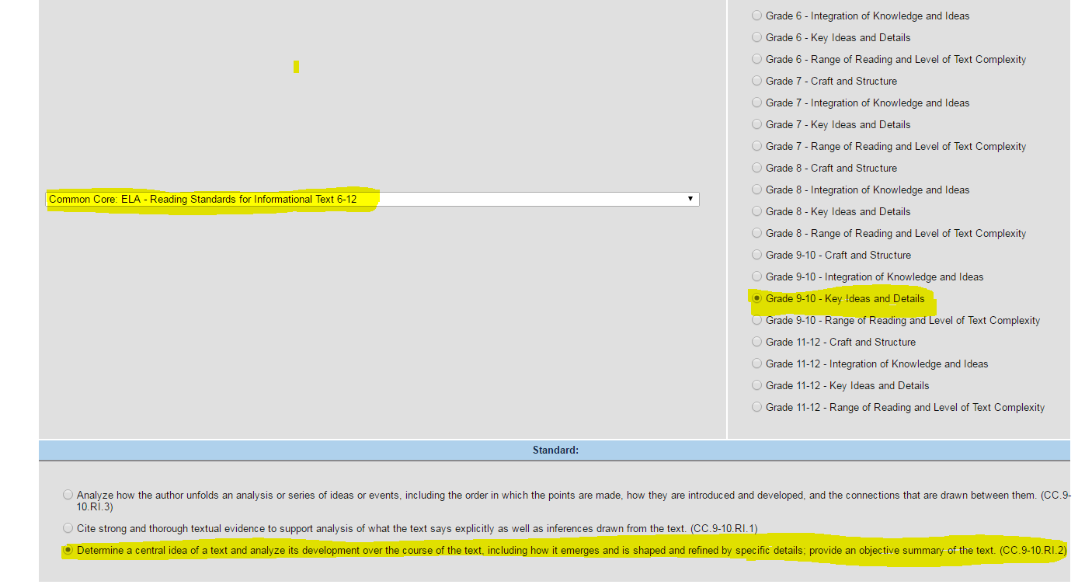
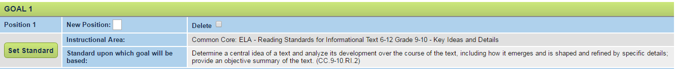
HOW TO CREATE OBJECTIVES
1. Michigan requires at least 2 objectives for each annual IEP goal.
2. In the snapshot below, Goal 1 has no objectives.
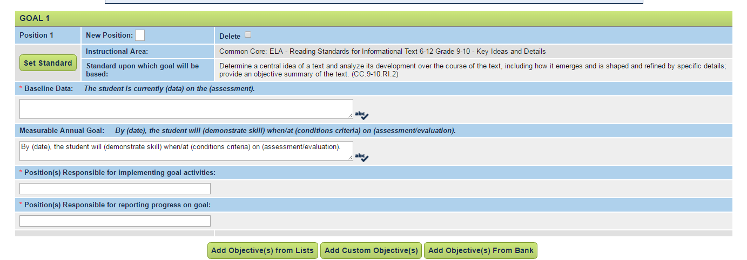
3. Objectives are added using the same process as adding a goal. See process above.
4. In the snapshot below, two objectives have been added to the goal. Notice the + next to Objective 1. By selecting the +, an objective folder opens.
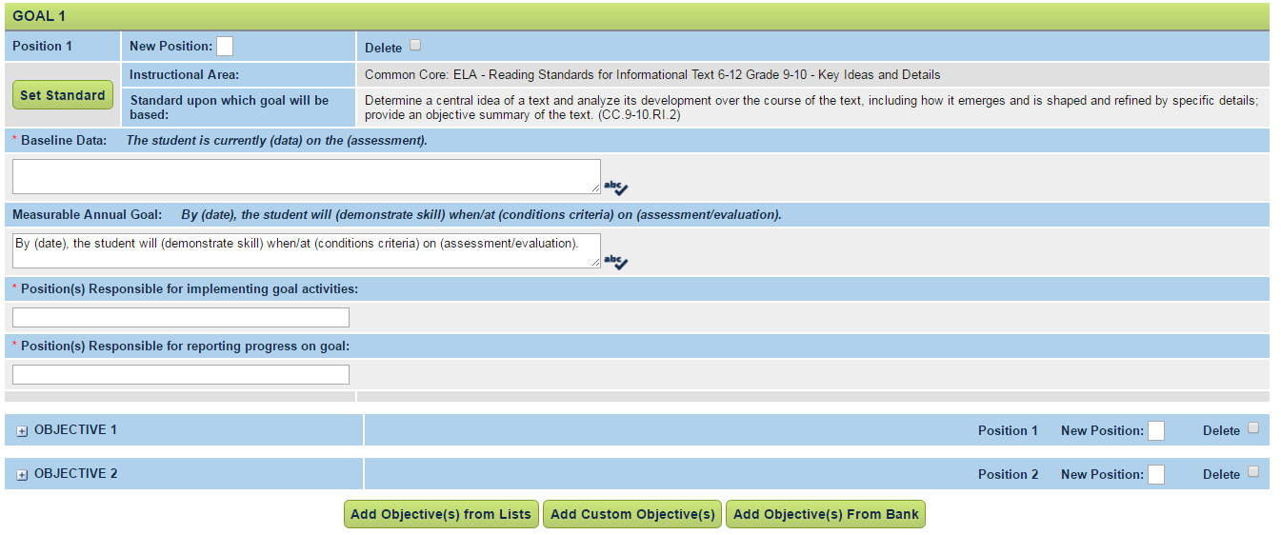

5. In this snapshot, the objective folder has been opened by selecting +. The user will now be able to add information to the objective: performance criteria, evaluation procedure, and evaluation schedule.
Please note that it is not necessary to add Starting % or Target %. If the user chooses to do so, a graph will print on the progress report. The % of success will be plotted along a target line based on the Target %.
Objectives must be measureable. Performance criteria should be in the the form: %, or x out of y times, and etc.
Dropdown menus are available for Evaluation Procedure and Evaluation Schedule.
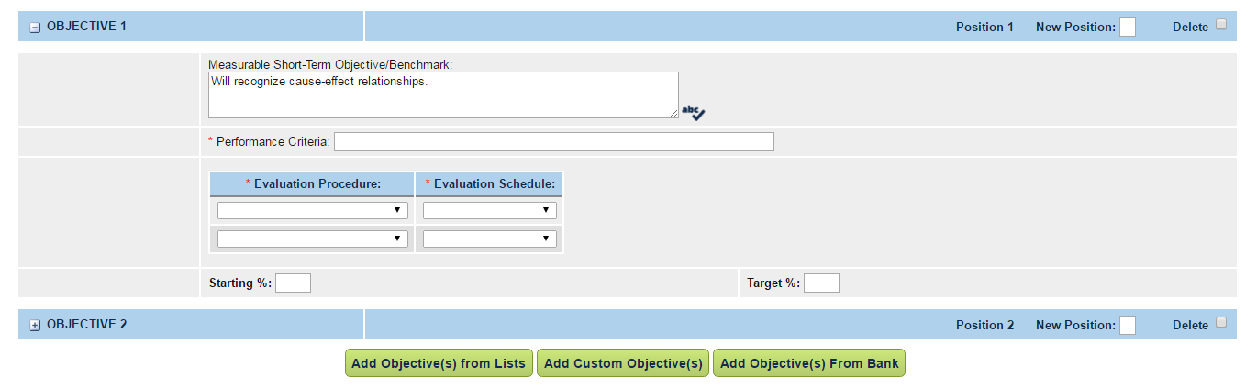
6. Save

DELETING AND POSITIONING Goals and Objectives
1. The user may delete a goal(s) and objective(s) from the workspace. The user may also reset the position of each goal and objective in the IEP workspace. See areas highlighted.
