EdPlan/Easy IEP How To: Adding and Removing Students from Caseload
1. Log into EdPlan/EasyIEP
2. Select Wizards
3. Select Caseload Setup Wizard

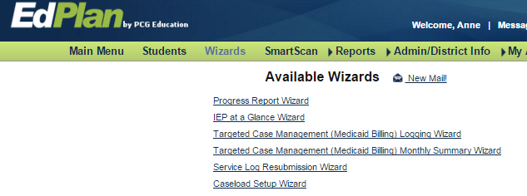
#3
#2

4. New window opens. Several students are already on caseload. To add another student select: Add More Students to Caseload

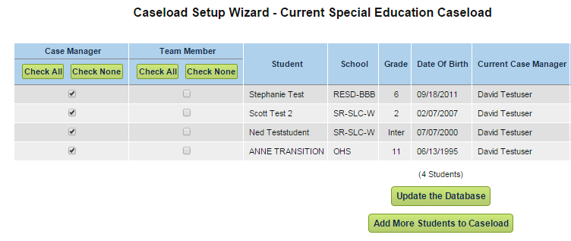
#4

5. New window opens. Enter the name of the student (5a) and select “view students” (5b).

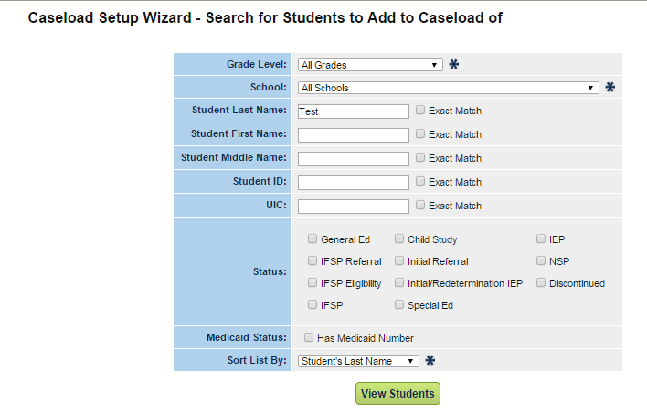
#5b
#5a

6. New window opens. All students with last name of TEST appear. Choose student by checking the box Case Manager or Team Member. In this example, Katherine Test is being added to the caseload by the case manager. Be sure Targeted Case Management appears and is checked. Select one of the green links at the bottom.

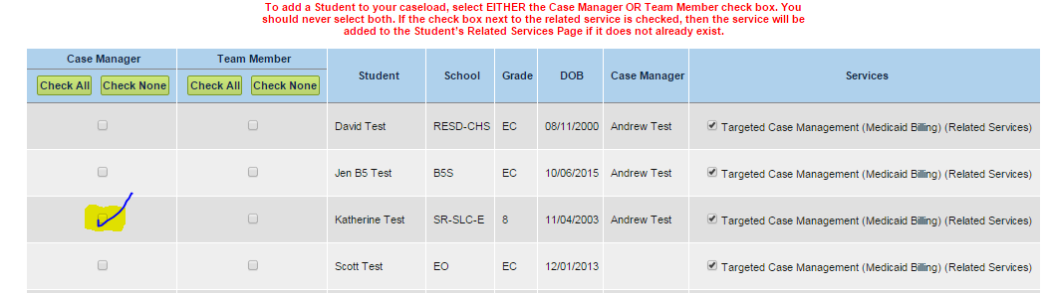

7. New window opens. Katherine has been added to the caseload. By adding Katherine to your caseload, you have deleted her from the previous case manager’s caseload. That person is not notified of the change. That person may still be a member of the team. Please notify that person so he/she can add Katherine to his/her caseload.

8. To remove a student, follow Steps 1-5. When caseload appears, UNCHECK the student and update the database.

