EdPlan/EasyIEP How To: Team Members
1. Log into EdPlan.
2. Select student from caseload.
3. On blue menu bar locate Special Education. Select. Dropdown list will appear. TEAM is located at the top. Select TEAM.
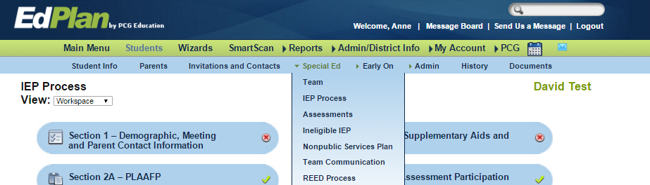

4. New window opens. Select Case manager, if appropriate. Current team members are listed.
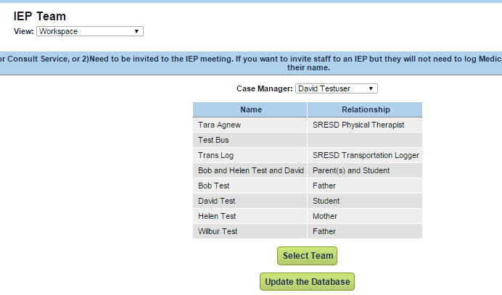
5. After selecting SELECT TEAM a new window opens. Select members from list provided by checking box next to person’s name. Select “Update the Database”.
6. Team members will be available for invitations and as participants on the IEP signature page.

