EdPlan: Documents Folder
1. Log into EdPlan; Student folder
2. Documents can be accessed from 2 locations: 1. Dropdown from Special Education in blue menu bar. 2. Documents on the menu bar.
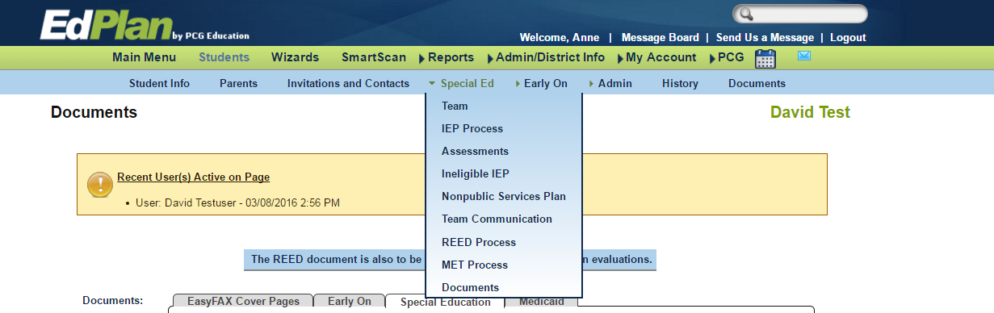
#2
#1

3. The Documents folder contains additional forms and a list of documents in either Draft or Final Status.
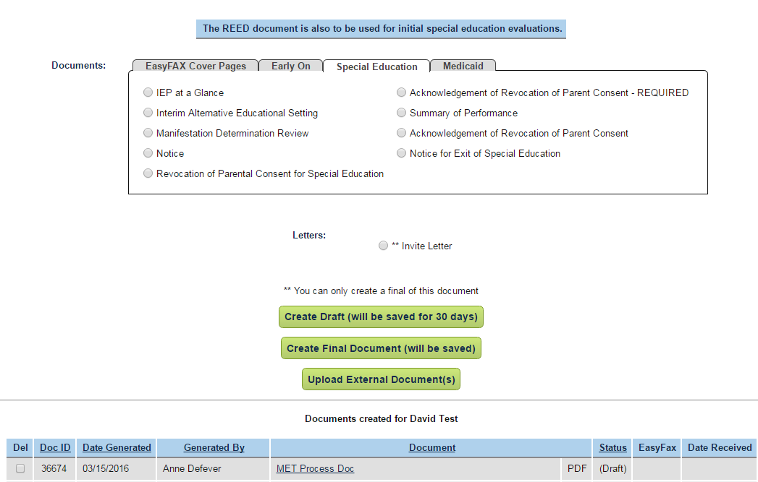
Invitation Letter
You can only create a final letter.
Documents completed in DRAFT or FINAL Status appear in a table at the bottom of the page.
Additional Forms

