EdPlan: Changing Length of School Week “HOW TO”
1. Log into EdPlan
2. Select Student
3. Select Student Info Tab

Student Info

4. Case managers have the ability to alter information on the Personal Information page.
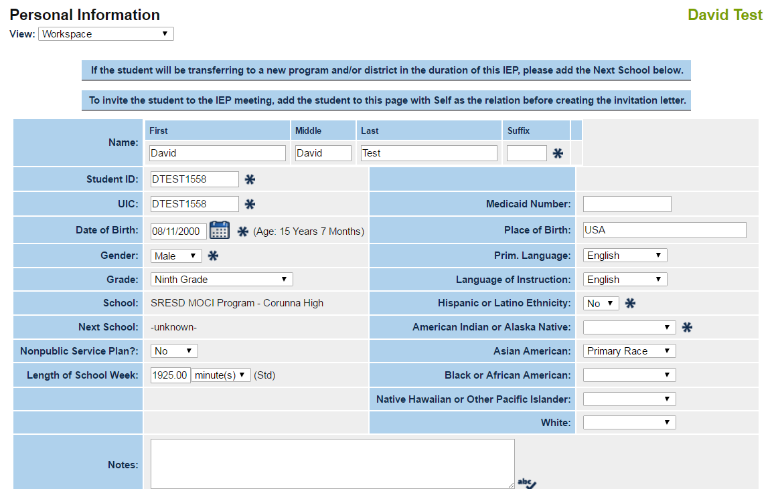
Length of School Week
5. Update the Database.

EdPlan: Change Length of School Week 2016 Page 1 of 1

