- Log into EdPlan
- Select Student
- Documents Tab
- A. Special Education tab, B. Select Summary of Performance
- Create Draft
# 3
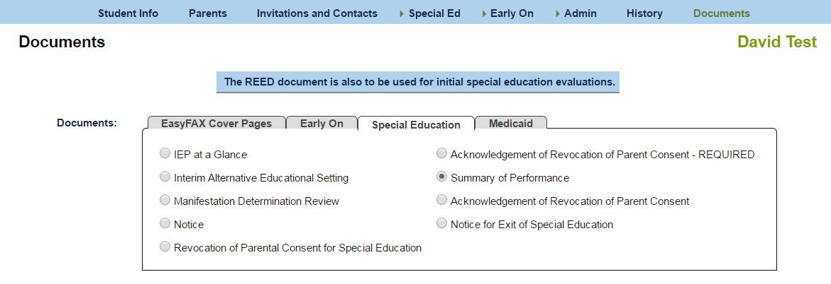
# 4B
# 4A
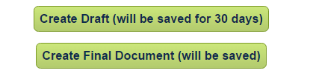
#5
- Complete information
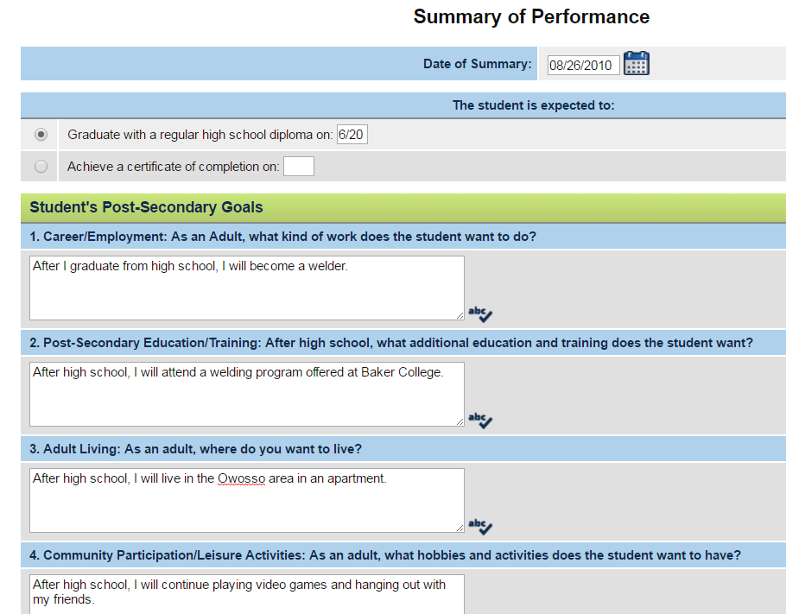
#6

- Summary of Academic Performance ( Do NOT check Documentation from psychologist.)
- Note in example below there are NO available assessments.
- How do you get information into this section?

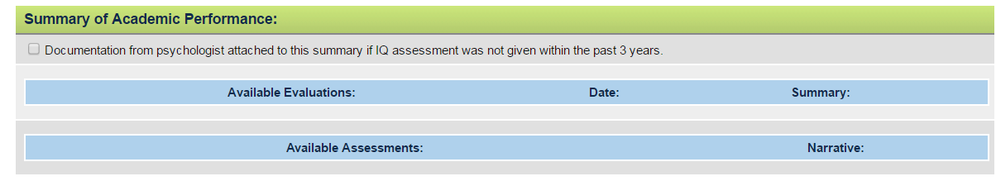
#7

- To enter Assessment information - Select Assessments from drop down menu under Special Ed.
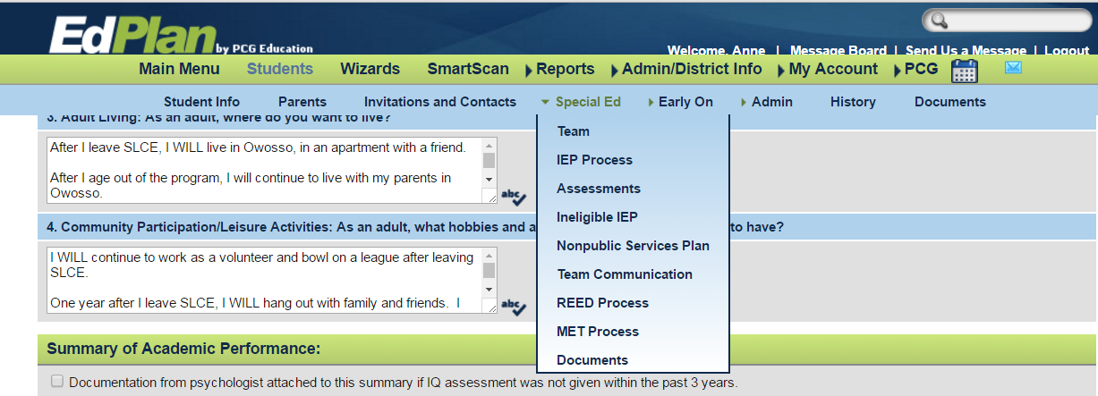
#8

- Opens a new window. Select Add Assessments.
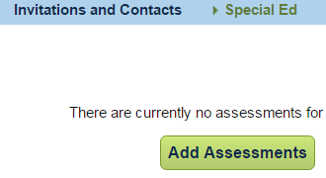
#9

- Add assessments – Complete information in correct area. Add ONE ASSESSMENT, THEN UPDATE THE DATABASE Before Adding another Assessment.
  - List of Assessments
  - Customized Assessment
  - Update the database
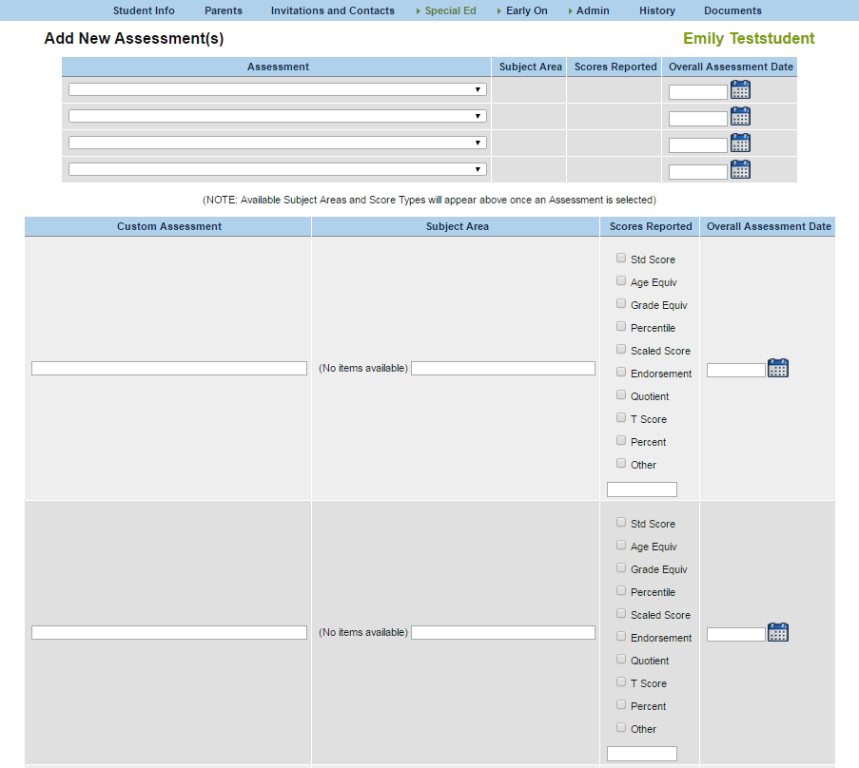
#10b Customize
#10a List

#10c Update

- After UPDATE the Database, the assessment appears in a table; click on DETAILS to add scores for the assessment.
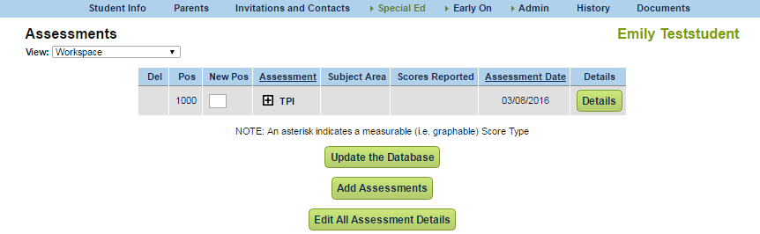
#11
- New window opens. Add Overall Assessment Narrative and input dates and scores. If you forgot to include a subject area, this page provides an opportunity to add another subtest. Update the Database.
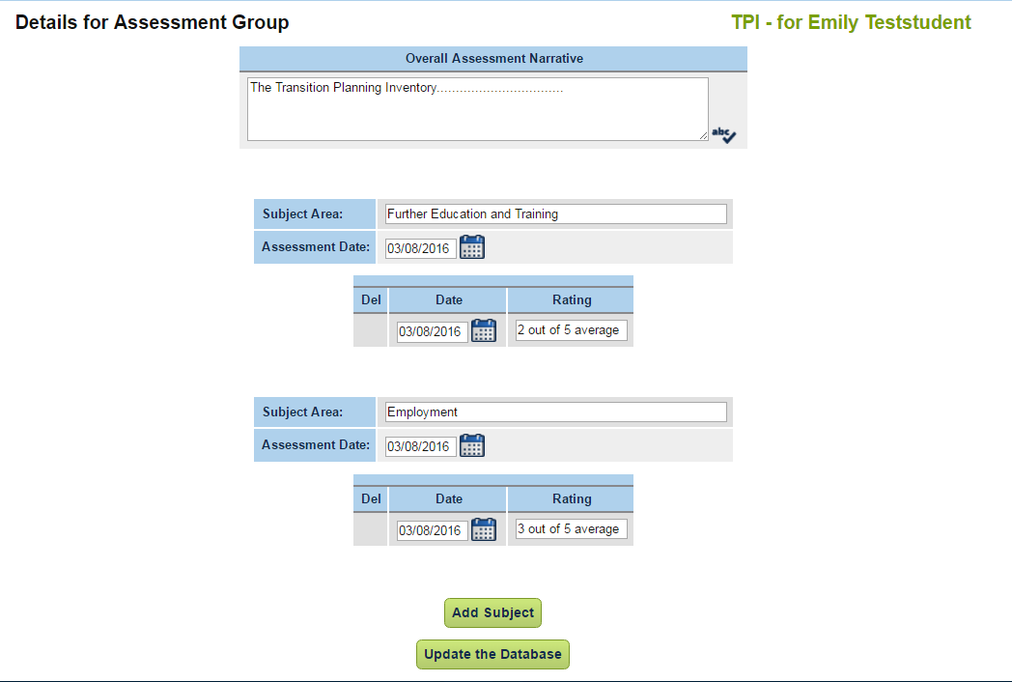
- To add more assessments, select Add Assessments. Follow the above process.

- To EDIT assessments, select EDIT All ASSESSMENT DETAILS. Make changes and Update the Database.
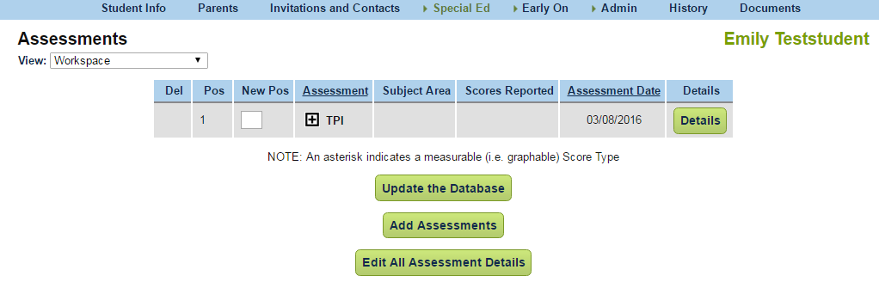
#14

- When all assessment information is entered, return to Documents, Select Special Education tab and A. Summary of Performance B. Draft. As previously stated in step #5 above.

- The Assessments will appear in the Summary of Performance draft. Check the assessment boxes to print on the final document. DO NOT Check Documentation from psychologist.
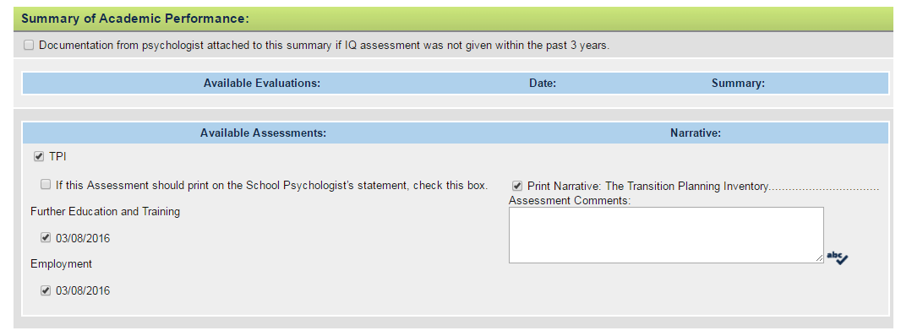
CHECK
CHECK
CHECK

- NOTE!!!! In the draft version Modifications/Accommodations Needed for Success in General Curriculum, DOES NOT APPEAR. The SOP will extract this information from the IEP.

- Summary of Functional Performance. Complete S for Strength or N for Need. Information should be based on the Transition Planning Inventory and student interview.

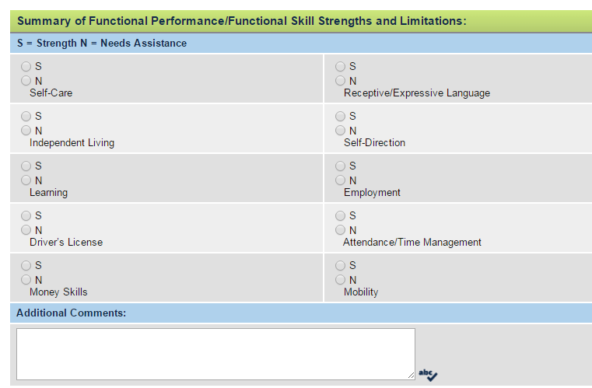

- A. Check boxes per student need. B. Check OTHER and Add Transition Life Links and Parent and Student Support Organizations.
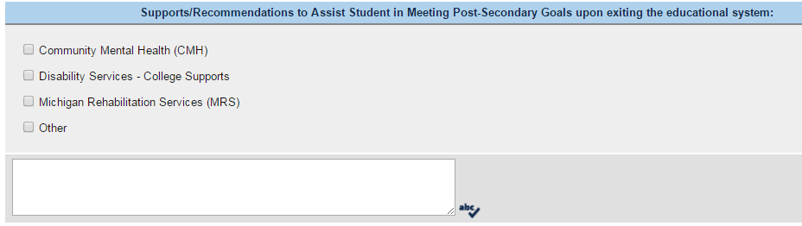
#19B
#19A
- Student Perspective: Interview student. The language should be based on the student’s response.
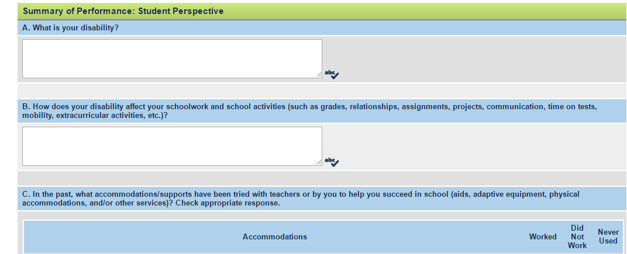

- Complete the additional 2 contacts. (Use for the SPP 14 Survey after high school). Check bottom box.
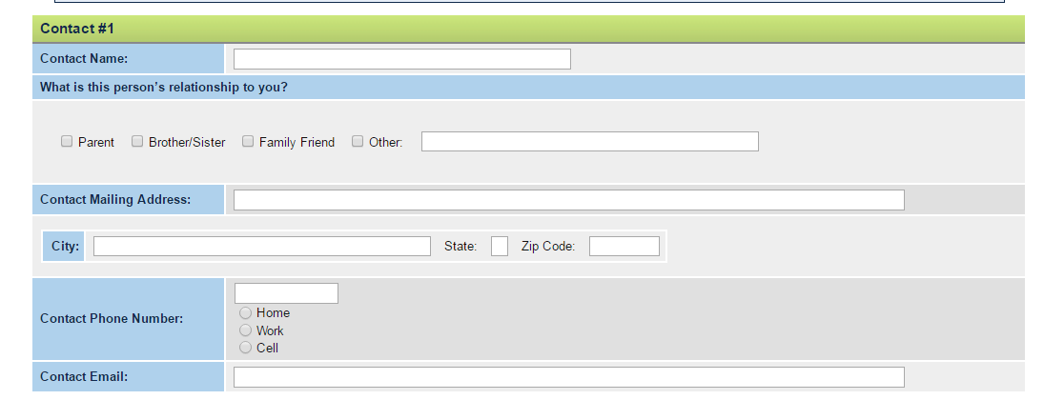
- Check bottom box. Select Save or Create Draft Document.
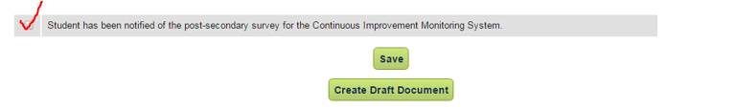

- To create FINAL Summary of Performance. Follow Step #5 above. Instead of choosing DRAFT, choose FINAL. The Final SOP will appear in the Documents folder.
FINAL

- When final has been produced, get signatures at the bottom of each page.
#22
