EdPlan/EasyIEP How To: View and Print
1. Log into EdPlan/EasyIEP.
2. Select student.
3. Select Documents Tab.
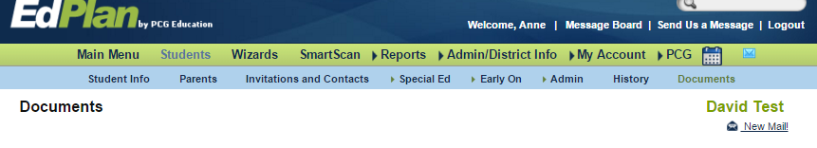
#1
4. New window opens. Scroll down. A list of documents will be available for viewing and printing. Select document.
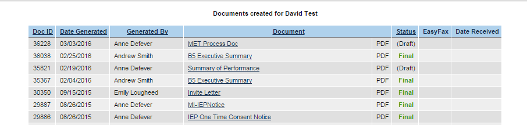

5. Selected document will open in new window.
6. Depending upon the version of software you are using, try moving the cursor on the screen. A visual of a printer and a “save” will appear on the screen for a few seconds. This version appears in the upper right hand corner of the screen.
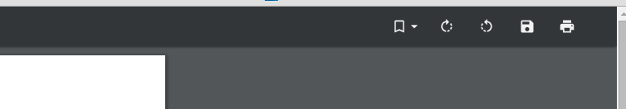
#6

